NATIONAL CONFERENCE ON SPORT PEDAGOGY
Organized by:
U.P. COLLEGE OF HUMAN KINETICS
ncsp2012.weebly.com
2012ncsp@gmail.com

Theme:
“Pedagogical Trends and Approaches in Physical
Education and Sport Science towards the 21st Century”

16 August 2012

Dear Sir/Madam,

Greetings!

The Departments of Physical Education and Sport Science of the U.P. College of Human Kinetics invites you to the National Conference on Sport Pedagogy from October 12-14, 2012, to be held at the University of the Philippines, Diliman, Quezon City. The theme, “Pedagogical Trends and Approaches in Physical Education and Sports Science towards the 21st Century“ is a reflection of the College’s commitment to share.

Endorsed by the Department of Education (DepEd) and the Commission on Higher Education (CHED), it aims to target at least 500 participants and gather together physical education and sport science teachers, researchers, coaches, fitness instructors, athletes and students from the different colleges and universities nationwide

The objectives of the conference/workshop are:

  - to disseminate information on trends, issues and approaches in teaching/training aspects in physical education and sport science settings for global competitiveness.
  - to enhance teaching/training skills on current physical activity offerings (sports, dance, fitness and athletic training).
  - to appreciate the significance of pedagogy in physical education and sport science programs
  - to foster collaboration and establish linkages among the different academic institutions and sports stakeholders.

In general, this conference aims to showcase the latest trends, issues and scientific approaches in teaching Physical Education.

We look forward to your participation and support of this momentous event. Your invaluable contribution to the success of this conference will result in the cooperation among those in the academe towards the attainment of a common vision, the strengthening of the Physical Education curriculum.

For information and/or reservations, you may contact the SECRETARIAT: Prof. MICHIKO ASERON at telephone number (02)2212419/(02)9296033; mobile (0922)8286157 or email: 2012ncsp@gmail.com.

Yours truly,

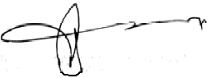

Prof. RONUALDO DIZER
Dean, U.P. College of Human Kinetics
Chairman, Organizing Committee

NATIONAL CONFERENCE ON SPORT PEDAGOGY
Organized by:
U.P. COLLEGE OF HUMAN KINETICS
ncsp2012.weebly.com
2012ncsp@gmail.com

Theme:
“Pedagogical Trends and Approaches in Physical
Education and Sport Science towards the 21st Century”

I. Authority
The Conference/Workshop entitled “National Conference on Sport Pedagogy” is organized by the College of Human Kinetics of the University of the Philippines; endorsed by the Commission on Higher Education (CHED) and in coordination with the Department of Education (DepEd).

II. Date and Place
The conference will be held from October 12-14 at the National Institute of Physics (NIP) Auditorium (NIP), U.P. Film Center and CHK Gym of U.P. Diliman, Quezon City.

III. Official Programme
The Official Programme can be downloaded at its official website: ncsp2012.weebly.com.

IV. Fees

Pre-registration (on or before September 28, 2012)
Professionals - Php 3,000 / person
Students – Php 1,000 / person

On-site registration (beyond September 28, 2012)
Professionals – Php 3,500 / person

Note: The fee is inclusive of conference bags and kits, freebies, conference banquet and two snacks each day. The fees may be paid in cash or manager’s check payable to U.P.. Foundation.inc/ (The distribution of the abovementioned items will be on a first come first serve basis)

V. Objectives of the Conference
At the end of the course, participants should be able to:

- To disseminate information on trends, issues and approaches in teaching/training aspects in physical education and sport science settings for global competitiveness.
- to enhance teaching/training skills on current physical activity offerings (sports, dance, fitness and athletic training).
- to appreciate the significance of pedagogy in physical education and sport science programs
- to foster collaboration and establish linkages among the different academic institutions and sports stakeholders.

VI. Methodology:
The utilization of Audio-visual aids and kits will be use to provide ease and comfort for the attendees. Lectures, workshops, discussion and demonstration will be the standard approach of teaching in order to achieve the above objectives.

VI. Participants profile
A maximum of 500 delegates representing physical education and sports science teachers, sports managers, coaches, trainers, athletes and students from the different colleges and universities nationwide will comprise the audience

VIII. Accommodation
For reservations, please refer to the official website at: ncsp2012.weebly.com. You may also contact Prof. Molly Cuerdo; Chairperson, Accommodation Committee at 0917-826-6559.

IX. Registration
Please fill up the prescribed registration forms and send to:

The Organizing Committee c/o Prof. MICHIKO ASERON –
SECRETARIAT
National Conference on Sport Pedagogy
Telefax: (02)9296033 / (02)2212419
Email: 2012ncsp@gmail.com

Registration Forms submitted on or before September 28, 2012 thru fax, mail and email will be consider as pre-registered, hence entitling the participants of the discounts and other first come first serve benefits. Participants who will register beyond September 28, 2012 will be subject to the on-site registration rate.

NATIONAL CONFERENCE ON SPORT PEDAGOGY
Organized by:
U.P. COLLEGE OF HUMAN KINETICS
ncsp2012.weebly.com
2012ncsp@gmail.com

Theme:
“Pedagogical Trends and Approaches in Physical
Education and Sport Science towards the 21st Century” OFFICIAL REGISTRATION FORM
Name: ______________________________________________ Date of Birth: _____________

School / Company and Address: _________________________________________________

Profession: __________________ Sport: _________________ Affiliation/Club: __________

Tel.: ________________________ Mobile Phone: ___________________________________

Email: _______________________ Mailing Address: _________________________________
Please check: Professional ____ Student ____

Group Registration
Names | Position
- attach additional form if necessary
Payment Details: Please check
____ Cash Amount: _P________________________
____ Check or Amount: _P________________________
____ Bank Payment Name / Bank- Branch / #: U.P. Foundation Inc. / Union Bank of
the Philippines - Acropolis Branch / Accnt. No. 00053-000682-0 Note:
Please make check payable to U.P. Foundation Inc. For Bank payment; kindly fax or email scanned Registration Form and Payment Slip to:
The SECRETARIAT
National Conference on Sport Pedagogy
Prof. MICHIKO ASERON cell phone 0922-828-6157
U.P. College of Human Kinetics, Diliman, Quezon City
Telefax: (02)9296033 / (02)2212419
Email: 2012ncsp@gmail.com

NATIONAL CONFERENCE ON SPORT PEDAGOGY
Organized by:
U.P. COLLEGE OF HUMAN KINETICS
ncsp2012.weebly.com
2012ncsp@gmail.com

Theme:
“Pedagogical Trends and Approaches in Physical
Education and Sport Science towards the 21st Century”

SIGN-UP FORM FOR WORKSHOP

Kindly fill up the following Workshop Activities that you will attend:

Per Workshop: 1 – First Choice; 2 – Second Choice; 3 – Third Choice

- Team Sports
- Basketball ____ 6. Rugby/Touch Football ____
- Volleyball ____ 7. Ultimate ____
- Baseball / Softball ____ 8. Dodgeball ____
- Football ____ 9. Handball ____
- Indoor Hockey ( Floorball) ____

- Individual Sports
- Table Tennis ____ 6. Arnis ____
- Self-Defense ( Judo0 ____ 7. Gymnastics ____
- Games on the Boulder Wall ____ 8. Taekwondo ____
- Fencing ____ 9. Badminton ____
- Swimming ____ 10. Cycling ____

- Dance
- Partner Dancing ____ 6. Tap Dance ____
- Folk Dance ____ 7. Belly Dancing ____
- Line Dancing ____ 8. Cheer Dancing ____
- Latin Dance ____ 9. Street Dance ____
- Zumba ____

- Fitness
- Philippine Games ____ 6. Balls and Bands ____
- Fitness and General Motor 7. Core/Functional Training ____
Ability testing ____ 8. Suspension Training ____
- Stretching ____ 9. Barre 3 ____
- Aerostrip ____ 10. Pilates ____
- Circuit Training ____

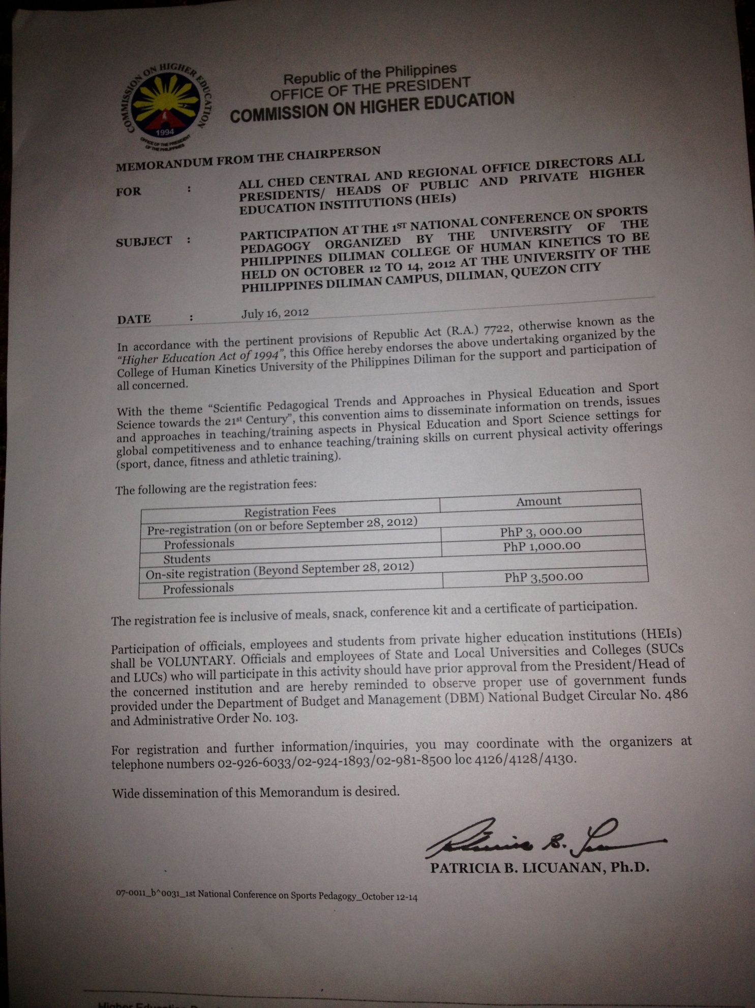

DepEd ADVISORY No. 395, s. 2012
In compliance with DepED Order No. 39, s. 2009
this advisory is issued for the information of DepEd officials and personnel
(visit DepEd website at www.deped.gov.ph)
August 15, 2012

FIRST NATIONAL CONFERENCE ON SPORT PEDAGOGY
The University of the Philippines’ College of Human Kinetics shall conduct the
First National Conference on Sports Pedagogy with the theme “Scientific Pedagogical
Trends and Approaches in Physical Education and Sport Science Towards the 21st
Century” on October 12-14, 2012 at the University of the Philippines (UP), Diliman
Campus, Quezon City.

The objectives of the Conference are to:

1. disseminate information on trends, issues and approaches in
teaching/training aspects in Physical Education and Sport Science
settings for global competitiveness;

2. enhance teaching/training skills on current physical activity offerings
(sports, dance, fitness and athletic training);

3. appreciate the significance of Sports Pedagogy in Physical Education
and Sport Science programs;

4. serve as an avenue for the sharing of knowledge and expertise among
the academe and sports professionals; and

5. foster collaboration and establish linkages among the different
academic institutions and sports stakeholders.

For more information, interested individuals may contact:

Prof. Michiko Aseron
College of Human Kinetics, University of the Philippines (UP)
Diliman, Quezon City
Telephone No.: (02) 981-8500 locals 4126/4128/4130; (02)2212419
Telefax Nos.: (02) 929-6033; (02) 924-1893
Mobile Phone No.: 0922-828-6157
E-mail Addresses: michimac03@gmail.com; oskies@yahoo.com; 2012ncsp@gmail.com
Website Address: http://ncsp2012.weebly.com

R:SGC/DA-first nat’l. conf. on sports pedagogy
August 10, 2012

